Cyclic Redundancy Check-

- Cyclic Redundancy Check (CRC) is an error detection method.
- It is based on binary division.

- Data , CRC generator, CRC bits

- CRC generator n bits – 0100 - 4bits
- CRC bit – (n-1) - 4-1 = 3
- CRC = Data + (n-1) 0’s / CRC generator

CRC Generator-

- CRC generator is an algebraic polynomial represented as a bit pattern.
- Bit pattern is obtained from the CRC generator using the following rule-

The power of each term gives the position of the bit and the coefficient gives the value of the bit.

Example-

Consider the CRC generator is x⁷ + x⁶ + x⁴ + x³ + x + 1.
Ex = X⁴ + 1 = 1 0 0 0 1
The corresponding binary pattern is obtained as-

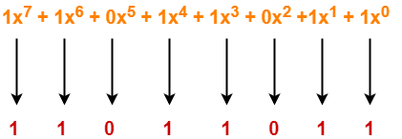

Thus, for the given CRC generator, the corresponding binary pattern is 11011011.

Properties Of CRC Generator-

The algebraic polynomial chosen as a CRC generator should have at least the following properties-

Rule-01:

- It should not be divisible by x.
- This condition guarantees that all the burst errors of length equal to the length of polynomial are detected.

Rule-02:

- It should be divisible by x+1.
- This condition guarantees that all the burst errors affecting an odd number of bits are detected.

Important Notes-

If the CRC generator is chosen according to the above rules, then-
- CRC can detect all single-bit errors
- CRC can detect all double-bit errors provided the divisor contains at least three logic 1’s.
- CRC can detect any odd number of errors provided the divisor is a factor of x+1.
- CRC can detect all burst error of length less than the degree of the polynomial.
- CRC can detect most of the larger burst errors with a high probability.

Steps Involved-

Error detection using CRC technique involves the following steps-

Step-01: Calculation Of CRC At Sender Side-

At sender side,
- A string of n 0’s is appended to the data unit to be transmitted.
- Here, n is one less than the number of bits in CRC generator.
- Binary division is performed of the resultant string with the CRC generator.
- After division, the remainder so obtained is called as CRC.
- It may be noted that CRC also consists of n bits.

Step-02: Appending CRC To Data Unit-

At sender side,
- The CRC is obtained after the binary division.
- The string of n 0’s appended to the data unit earlier is replaced by the CRC remainder.

Step-03: Transmission To Receiver-

- The newly formed code word (Original data + CRC) is transmitted to the receiver.

Step-04: Checking at Receiver Side-

At receiver side,
- The transmitted code word is received.
- The received code word is divided with the same CRC generator.
- On division, the remainder so obtained is checked.

The following two cases are possible-

Case-01: Remainder = 0

If the remainder is zero,
- Receiver assumes that no error occurred in the data during the transmission.
- Receiver accepts the data.

Case-02: Remainder ≠ 0

If the remainder is non-zero,
- Receiver assumes that some error occurred in the data during the transmission.
- Receiver rejects the data and asks the sender for retransmission.

Also Read- Parity Check

PRACTICE PROBLEMS BASED ON CYCLIC REDUNDANCY CHECK (CRC)-

Problem-01:

A bit stream 1101011011 is transmitted using the standard CRC method. The generator polynomial is x⁴+x+1. What is the actual bit string transmitted?

Data - 1101011011
CRC bit - x⁴+x+1 - 10011
N = 5 , 5-1 = 4
= Data + (n-1) 0’s
= 11010110110000 / 10011

Solution-

- The generator polynomial G(x) = x⁴ + x + 1 is encoded as 10011.
- Clearly, the generator polynomial consists of 5 bits.
- So, a string of 4 zeroes is appended to the bit stream to be transmitted.
- The resulting bit stream is 11010110110000.

10011. -
11010110110000.

Now, the binary division is performed as-

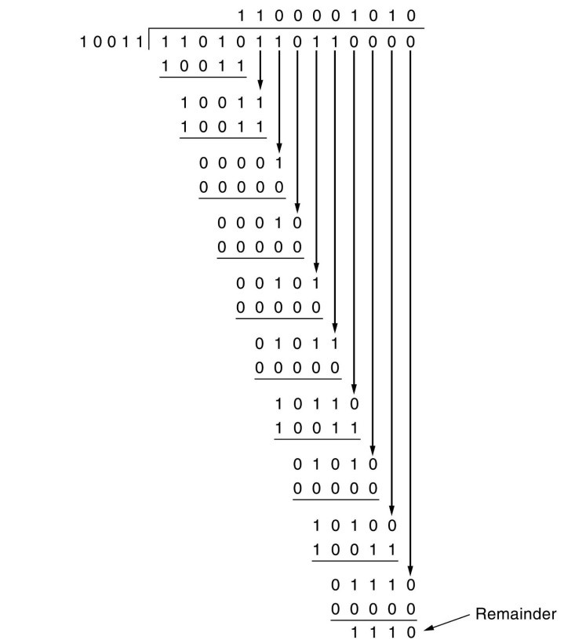

From here, CRC = 1110.
Now, 11010110110000. -
Sender side CRC bit - 11010110111110.

- The code word to be transmitted is obtained by replacing the last 4 zeroes of 11010110110000 with the CRC.
- Thus, the code word transmitted to the receiver = 11010110111110.

Receiver side = Original bit / 10011

- 11010110111110. / 10011
10011

10011
10011

10111
10011

10011
10011

0000

Problem-02:

A bit stream 10011101 is transmitted using the standard CRC method. The generator polynomial is x³+1.
- What is the actual bit string transmitted?
- Suppose the third bit from the left is inverted during transmission. How will receiver detect this error?

Solution-

Part-01:

- The generator polynomial G(x) = x³ + 1 is encoded as 1001.
- Clearly, the generator polynomial consists of 4 bits.
- So, a string of 3 zeroes is appended to the bit stream to be transmitted.
- The resulting bit stream is 10011101000.

Now, the binary division is performed as-

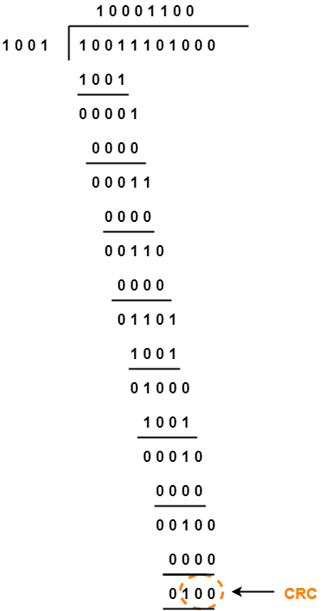

From here, CRC = 100.
Now,
- The code word to be transmitted is obtained by replacing the last 3 zeroes of 10011101000 with the CRC.
- Thus, the code word transmitted to the receiver = 10011101100.

Part-02:

According to the question,
- Third bit from the left gets inverted during transmission.
- So, the bit stream received by the receiver = 10111101100.

Now,
- Receiver receives the bit stream = 10111101100.
- Receiver performs the binary division with the same generator polynomial as-

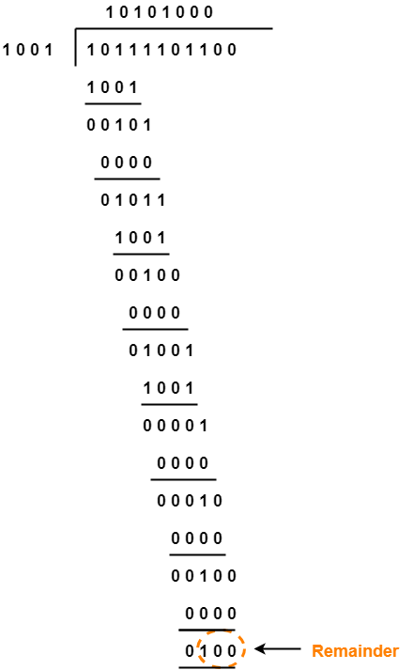

From here,
- The remainder obtained on division is a non-zero value.
- This indicates to the receiver that an error occurred in the data during the transmission.
- Therefore, receiver rejects the data and asks the sender for retransmission.

